**Anita Knight**

**Project Status Report II**

**Application name:** Federal Income tax estimator

**Purpose**: Provide estimate of federal taxes to be owed for tax payer who files fairly simple return

**Reason**: I found this to be a very useful tool on many occasions to plan for tax filing and decide what withholdings should look like

**Goals**: Be able to provide a reasonable estimate of taxes owed for the following:

Income types: wages, social security ,retirement, interest/dividends

Provide estimating tool for itemized deductions, then determine if standard or itemized deduction is better

**Target audience:** Anyone who files simple tax return

**Application outline:**

Data to be input:

Filing status

Special circumstances: (over 65, blind)

Income in 4 categories: wages, social security, retirement, interest/dividends

Other adjustments to income: IRA or retirement contributions

Taxes withheld or paid

(Optional): Itemized deduction categories: taxes paid, medical expenses, gifts to charity, interest paid

Results:

Estimated total tax

Estimated amount due

Percentage of total income

**PROJECT STATUS:**

Completed items:

* General mockup of data entry window complete
* Pseudocode for the following functions are complete:
  + Calculate Total Income
  + Calculate Standard Deduction
* Design notes made for function “Calculate total tax”
* Test plan set up (see below)
* User manual version 1

Next steps:

* Finish algorithm for tax calculations
* Set up test cases in Excel for bottom up testing of tax calculations
* Code window1 and window2 setup
* Do “batch” testing of tax calculation modules
* Finish coding

Filing status:

Mockup of Window #1 Layout

○ Single ○ Married/joint ○ Married/separate ○ Head of household

Estimated income

Wages:

Interest/Dividends:

Social security:

Retirement:

Adjustments to income

IRA contributions:

Retirement contributions:

Taxes withheld:

Calculate Est Tax

Special situations:

**□**  Taxpayer is 65 or older **□**  Taxpayer is blind

**□**  Spouse is 65 or older **□**  Spouse is blind

Clear All

Enter itemized deductions All

Deductions:

Taxes paid:

Medical expenses:

Gifts to charity:

Interest paid:

**Design Notes**

All numeric input fields will be set up as float but input will be rounded to nearest dollar.

Filing status will be choice of 4 radio buttons. This will be the only required field.

“Special situations” will be choice of 4 checkboxes.

Pseudocode for anticipated functions:

* Calculate taxable income

Total income = wages + int/div + social sec + retirement

Taxable income = Total income – IRA contribution – retirement contribution

* Calculate total tax

Determine amounts at each tax level (algorithm to be developed- 7 levels of tax- see table below)

Calculate tax for each level (based on table of tax percentages )

Total tax = taxLevel1 + taxLevel2 + taxLevel3 + taxLevel4 + taxLevel5 + taxLevel6 + taxLevel7

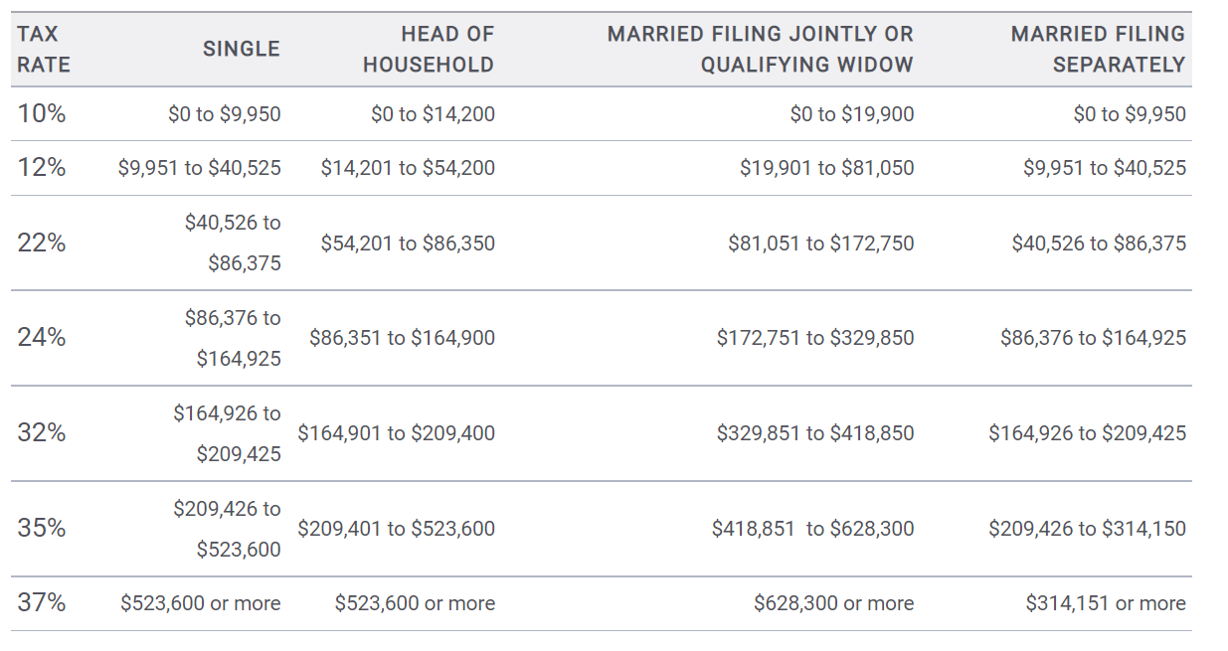

* Calculate standard deduction

If Status == Single or Status == Married-Sep:

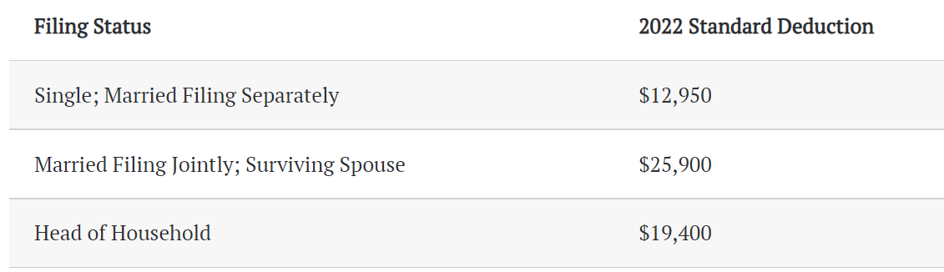 standDeduction = 12950

elIf Status == Married-Joint:

standDeduction = 25900

elIf Status == Head-House:

standDeduction = 19400

If “over 65” is True:

Over65credit = 1700

Else:

Over65credit = 0

If “blind” is True:

Blindcredit = 1700

Else:

Blindcredit = 0

If “spouse over 65” is True:

SpOver65credit = 1700

Else:

SpOver65credit = 0

If “spouse blind” is True:

SpBlindcredit = 1700

Else:

SpBlindcredit = 0

StandDeduction = StandDeduction + over65Credit + blindCredit + Spover65Credit + SpblindCredit

**Test Plan**

Some bottom-up testing will be used because of the fact that there are so many variables. The tax calculation modules will be tested with a list of test cases found in a .TXT file, which will be created using Excel. A list of test cases is currently under development.

**User Manual**

Simple federal income tax calculator

This application will provide an estimate for any Federal taxes that might be owed based on the estimates provided by the user. The calculator is designed for simple tax situations only, but will allow a choice of filing status (Single, Married/filing jointly, Married/filing separately, Head of Household).

Some specific situations that are excluded are:

* Calculations on capital gains
* Child tax credits
* Earned income credits

As an option, the user can enter itemized deductions to determine if itemizing is preferable to the standard deduction.

**Instructions:**

*All numeric entries will be automatically rounded to the nearest dollar.*

*All entries should be the estimated total for the entire year.*

1. Choose the filing status that applies to your situation. **This information is required.**
2. In the Estimated Income section, enter your yearly estimates in each of the 4 categories that apply to your situation. The program will round any cents to the nearest dollar.
3. In the Adjustments to Income section, enter either of the common adjustments to your income. This should be the amount for the entire year. Again, the program will round any cents to the nearest dollar.
4. Enter the amount of taxes that you anticipate will be withheld from your income. The amount should be estimated for the entire year. Program will round any cents to the nearest dollar.
5. If any of the following situations apply, check the appropriate box:
   * Taxpayer is 65 or older
   * Taxpayer is blind
   * Spouse is 65 or older
   * Spouse if blind
6. Optionally, if you would like the program to compare your standard deduction to your itemized deductions, you can enter estimates for your itemized deductions. Press the “Enter itemized deductions” button to make those entries.
7. When you are finished with all of your input, press the “Calculate estimated tax” button. Your results will be displayed in the next window. After you review the results, close the results window by clicking the X in the top right corner.
8. If you would like to revisit any of your entries, you can do so. After making any changes, press the “Calculate estimated tax” button to review the results.
9. To clear all entries on the screen and start over, press the “Clear All” button.
10. To exit the program, click the X in the top right corner.